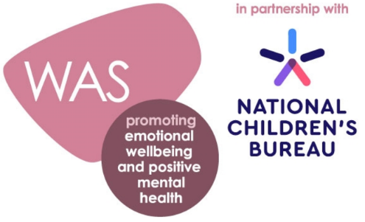

Wellbeing Award for Schools Case Study

Co-ordinator/Headteacher’s name: Jennifer Sacks, Assistant Head and Designated Safeguarding Lead (coordinator)

School name: Woodford Green Preparatory School (WGPS)

Location: Woodford Green, Essex

Brief summary of your school: Independent Preparatory School

Why did your school decide to take the Wellbeing Award for Schools (WAS)?
We thought our wellbeing provision was good but wanted to find strategies to make it excellent.
What particular issue(s) did the WAS help you to identify?
A lack of confidence initially from staff in knowing how to identify emotional concerns and next steps in what to do.
What changes did you make as a result of this?
All staff are on a journey to become MHFA trained, with 16 staff trained so far and we have offered this training to others. We also recognised that post pandemic staff had suffered from trauma, and we employed an external counsellor to meet with staff on a weekly basis, confidentially. All staff underwent INSIGHT training to best identify how to work well with others. Since implementing these changes, 100% of staff surveyed have said they can identify emotional issues and would know what to do.
What impact did this have?
Staff confidence and satisfaction has grown tremendously. We also recognised, particularly in lockdown, that parents needed support and offered workshops on anxiety in children, zones of regulation (which is used throughout the school), check in phone calls to parents; the Family Links programme and signposting of websites that parents can access for further support.

Since achieving the Award, what direct impact(s) has the WAS had on developing parent partnerships and pupil achievement?
A happy child will thrive, and in listening to pupils about their choices and putting into action things that they have requested they feel heard and appreciated. For example, we have a dedicated counselling room now which is used by our pupils, as well as the learning support room which is used by our learning support mentor. All pupils know who they can speak to and feel that they will be listened to taken seriously. With anxieties taken away, pupils are more focused in class and therefore achieve well academically.

What are your next steps?
To expand the Family Links provisions for parents, offering bespoke Early Years and 'Talking Teens' workshops to help support parents manage their family lives. For staff, to continue to invest in staff CPD around emotional wellbeing and continue our termly wellbeing surveys so we can respond to any emerging concerns. For pupils, to expand our use of the Learning Mentor system (as our Learning Mentor only works part time) so that more children can be regularly seen in a week. We would also like to create a digital way of children informing staff if they have worries, as sometimes they don't want to be seen to be talking to the teacher.

How would you describe the whole experience from start to finish and achieving the award?
Starting the award just prior to the pandemic certainly made it challenging, but it also highlighted the crisis surrounding wellbeing and emphasised the importance of talking about emotions and finding ways of regulating our emotions. As a school, we are in a far stronger position that we were 3 years ago, and the Wellbeing Award for Schools feels like a fitting embodiment of the commitment the school has shown to its pupils, staff and parents wellbeing.

How would you recommend this award to a school thinking about undertaking the process?
The benefits of doing the award far outweigh the time pressures that come with it, and if you are working in a school which does wish to improve its wellbeing provision then this is an excellent way of doing so.
Lastly, please provide a short testimonial from your headteacher.
As our headteacher was not directly involved in the award, it would be better for this to come from myself, the Assistant Head, as I was the coordinator. I am very proud of everyone's input into the Wellbeing Award for Schools. As a team we listened to our staff, parents, and pupils about the changes they wanted to see and as realistically possible, we implemented them. Our pupils feel supported and heard; we have a common language through the school via the Zones of Regulation and our parents truly believe in our Open-Door policy and take advantage of our Family Links programme, which always has a waiting list. For our staff, they know in times of crisis that SLT are approachable and will support them however possible. We have created a counselling room for confidential counselling sessions for staff, which is paid for by the school. All staff have had stress management training. All staff have had insights management training and all staff will be offered MHFA training. Furthermore, our staff wellbeing policy is now in our staff handbook, clear for all to see our commitment to wellbeing at WGPS.

